API Testing

Theme: User Account Management System
Section A: Conceptual Questions

1. You are testing a user account system that exposes application programming interfaces instead of a user interface. Explain why application programming interface testing is preferred in this scenario.
- When a user account system exposes APIs instead of a user interface, testing must focus on the APIs directly. The reasons are:
1. No UI Layer Available
- Since the system does not provide a graphical interface, traditional UI testing is impossible.
- APIs are the only way to interact with the system, so they must be validated thoroughly.
2. Direct Validation of Business Logic
- APIs handle core functions such as login, authentication, profile updates, and logout.
- Testing them ensures the functional correctness of the system without relying on a front-end.
3. Faster and More Reliable
- API tests bypass UI rendering and user interactions, making them quicker and less prone to flakiness.
- They provide stable regression coverage even if the UI changes later.

4. Early Testing in SDLC
- APIs can be tested as soon as backend services are available, even before the UI is developed.
- This enables early defect detection and reduces cost of fixing issues.
5. Integration Readiness
- APIs are consumed by mobile apps, web apps, or third-party systems.
- Testing ensures compatibility, data integrity, and security for all integrations.
6. Broader Coverage
- API testing validates request/response formats, error handling, authentication, and session management.
- It ensures the system behaves correctly under valid and invalid scenarios.

2. A tester validates data using application programming interfaces before the user interface is ready. Explain the advantages of this approach.

1. Early Testing in the Development Cycle
- APIs are usually available before the UI is built.
- This allows testers to start validation earlier, catching defects sooner and reducing the cost of fixing them.
2. Faster Feedback
- API tests run quickly compared to UI tests because they bypass rendering and user interactions.
- Developers receive immediate feedback on backend logic and data handling.
3. Independent of UI Changes
- UI elements often change during development, which can break UI tests.
- API tests remain stable since they validate the core business logic directly.
4. Improved Coverage
- APIs expose all functionalities (e.g., login, profile update, logout).
- Testers can validate positive, negative, and edge cases thoroughly, ensuring robust coverage.
5. Integration Readiness
- APIs are consumed by multiple clients (mobile apps, web apps, third-party systems).
- Testing them early ensures compatibility and reliability across integrations.
6. Data Accuracy and Security Validation
- API testing verifies request/response formats, data integrity, and error handling.
- Security aspects like authentication tokens and session management can be validated before UI is available.
7. Reduced Dependency
- Testers don’t need to wait for UI developers to finish their work.
- This parallel progress accelerates overall project timelines.

3. An application programming interface returns a successful status code but incorrect data. Explain how response validation should be handled.
. Validate Response Body
- Ensure the returned data matches the expected schema (fields, types, formats).
- Example: If the API returns user profile details, verify that username, email, and phone are present and correct.
2. Business Logic Validation
- Check that the data aligns with business rules.
- Example: A user’s account status should be “Active” after successful login, not “Inactive.”
3. Cross-Verification with Backend
- Compare API response data with the database or backend system.
- This ensures the API is not just returning data but returning the correct and consistent data.
4. Negative and Boundary Testing
- Validate how the API behaves with invalid inputs or edge cases.
- Example: If requesting a non-existent user ID, the API should return an error, not a success code with wrong data.
5. Schema and Contract Testing
- Use tools like Postman, RestAssured, or Pact to enforce API contracts.
- This ensures the response structure and values are consistent with specifications.
6. Assertions in Automation
- Automation scripts should assert both:
  - Status Code (e.g., 200, 201).
  - Response Content (e.g., email field matches expected value).
- Example in pseudo-code:
java
assertEquals(response.getStatusCode(), 200);
assertEquals(response.jsonPath().get("email"), "testuser@example.com");
7. Error Logging
- If incorrect data is returned, log it as a functional defect rather than a connectivity issue.
- This helps developers trace logic errors in backend processing.

4. Explain how request headers and request body content affect application programming interface behaviour.
1. Request Headers
Headers are metadata sent along with an API request. They influence how the server interprets and processes the request. Examples:
- Authentication/Authorization:
  - Authorization: Bearer <token> → Determines if the user is allowed to access the resource.
- Content-Type:
  - Content-Type: application/json → Informs the server about the format of the request body.
- Accept:
  - Accept: application/xml → Tells the server what response format the client expects.
- Custom Headers:
  - Used for tracking, correlation IDs, or versioning.
👉 Impact: Incorrect or missing headers can cause authentication failures, wrong data formats, or rejected requests.
2. Request Body Content
The body carries the actual data payload sent to the API, especially in POST, PUT, or PATCH requests. Examples:
- Login Request:
json
{
"username": "testuser",
"password": "securePass123"
}
→ Determines whether login succeeds or fails.
- Profile Update Request:
json
{
"email": "newemail@example.com",
"phone": "9876543210"
}
→ Updates user details in the backend.
Impact:
- If the body is malformed (e.g., missing required fields), the API may return errors.
- If the body contains incorrect values, the API may process wrong data, leading to functional defects.
- Proper validation ensures data integrity, security, and business rule compliance.

5. A protected application programming interface returns an unauthorized response. Explain how authentication validation should be performed.
1. Verify Authentication Mechanism
- Confirm the API requires valid credentials (username/password, tokens, API keys).
- Ensure that requests without proper authentication are rejected with 401 Unauthorized.
2. Check Request Headers
- Validate that headers such as Authorization: Bearer <token> or API-Key are mandatory.
- Ensure missing or malformed headers trigger unauthorized responses.
3. Token Validation
- Confirm that expired, revoked, or invalid tokens are rejected.
- Validate token refresh mechanisms (e.g., refresh tokens must generate new valid access tokens).
4. Role-Based Access Control
- Ensure users with insufficient privileges receive 403 Forbidden instead of accessing protected endpoints.
- Example: A standard user should not be able to access admin-only APIs.
5. Negative Testing
- Attempt login with invalid credentials → API should return 401 Unauthorized.
- Attempt access with expired token → API should return 401 Unauthorized.
- Attempt access with valid token but insufficient role → API should return 403 Forbidden.
6. Consistency Across Endpoints
- All protected endpoints must enforce authentication uniformly.
- No endpoint should bypass authentication checks.
7. Automation Assertions
- Automation scripts should assert both:
  - Status Code (401/403 for unauthorized access).
  - Error Message (e.g., "Unauthorized access" or "Invalid token").

Section B: Practical Application Tasks

1. Collection Setup: Create a new Postman Collection titled "User Account Management." Organize your requests into folders (e.g., "Positive Tests," "Negative Tests") and set up a Collection Variable for the base_url to easily switch between environments.
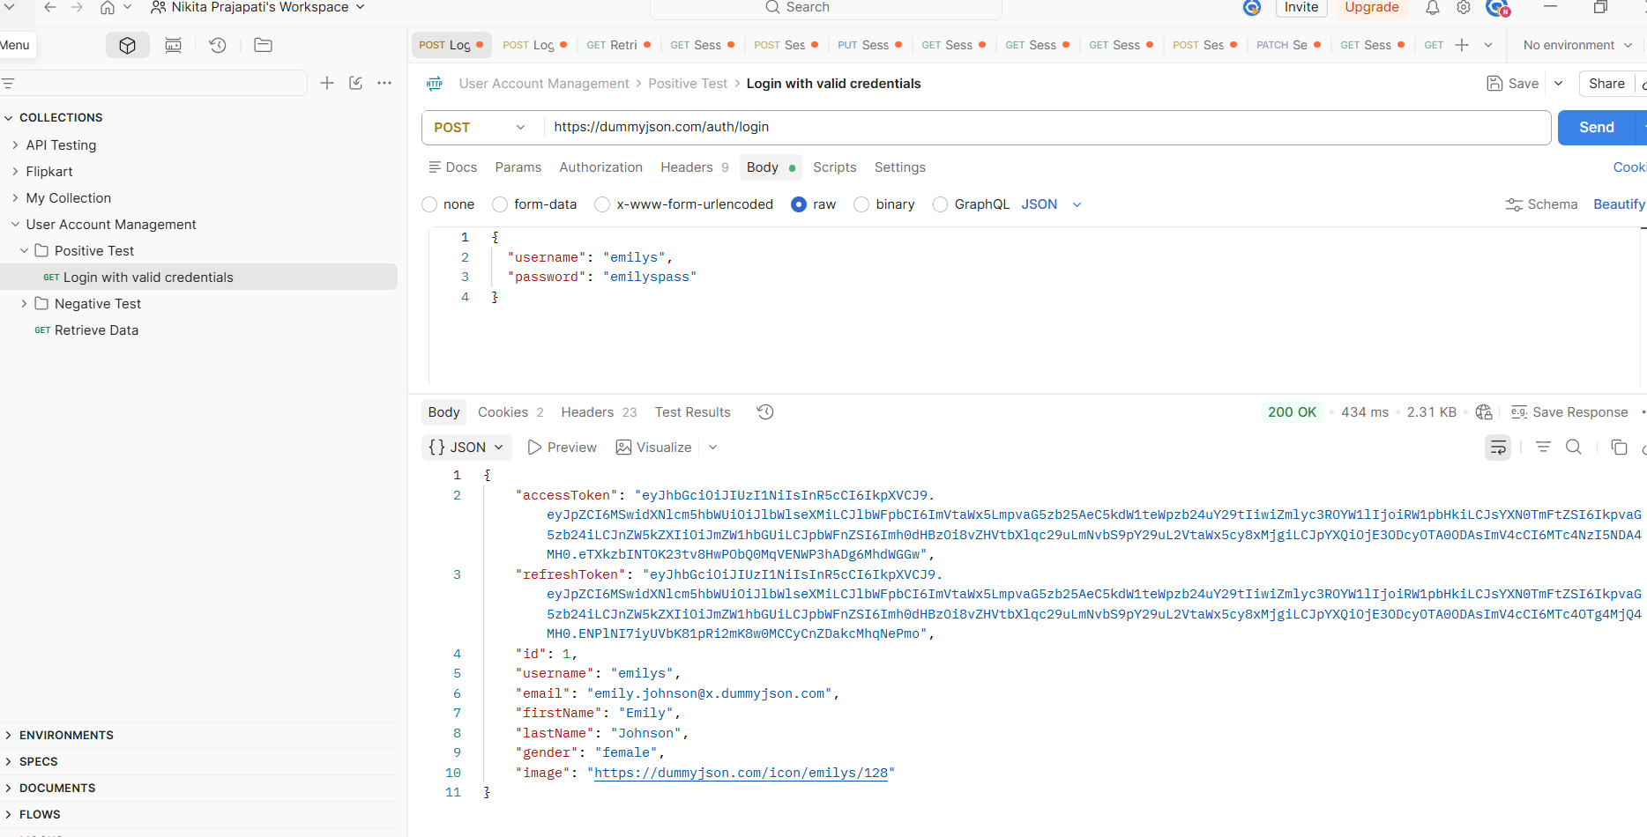

2.Retrieve Data (GET): Send a GET request to the /users or /users/{id} endpoint. In the Tests tab, write a script to validate that the response structure is a JSON object and that mandatory fields like username and email are present.

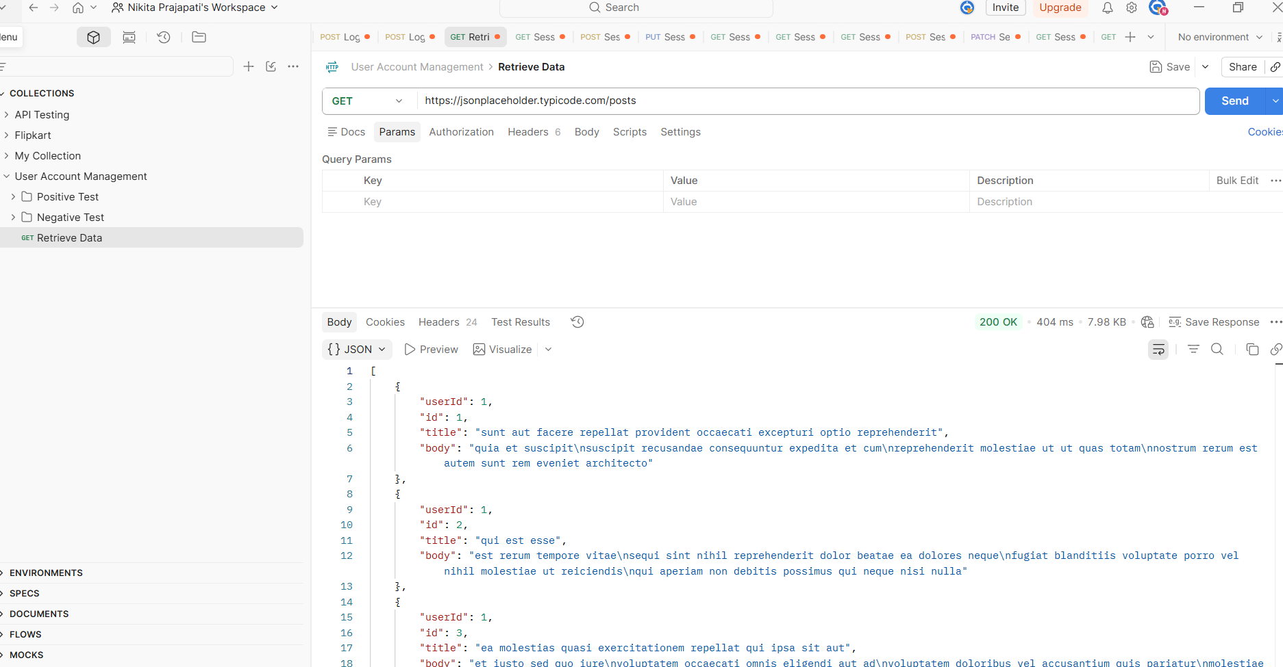

4. Account Update (PUT): Send a PUT request to modify an existing user’s details (e.g., changing the status or phone_number). Validate that the response reflects the updated values and that the status code is 200 OK.

- PUT request → Used to update an existing resource (in this case, a user account).
- Modify details → Example fields include status or phone_number.
- json code
{
"status": "active",
"phone_number": "9876543210"
}

Check the status code → The server should return 200 OK, which means the update was successful.
Check the response body → The returned JSON should reflect the updated values. For example:
Json:
{
"id": 101,
"name": "Nikita",
"status": "active",
"phone_number": "9876543210"
}

Section C: Mini Capstone Project – End-to-End Application Programming Interface Testing Context .
You are assigned as an Application Programming Interface Test Engineer responsible for validating backend services.

1. Test Planning Document: Prepare a Test Plan covering scope, objectives, test data strategy, authentication approach, risks, and validation techniques.
Test Plan – End-to-End API Testing
1. Scope
- Inclusions:
  - Validation of backend REST/GraphQL services.
  - Functional testing of CRUD operations (Create, Read, Update, Delete).
  - Authentication & authorization flows (e.g., OAuth2, JWT).
  - Response validation (status codes, headers, payload).
  - Performance testing (latency, throughput).
  - Error handling and boundary conditions.
- Exclusions:
  - Frontend UI validation.
  - Third-party integrations not under test scope.
2. Objectives
- Ensure APIs meet functional and non-functional requirements.
- Validate secure access and proper authentication mechanisms.
- Confirm data integrity across requests and responses.
- Detect defects early in backend services before UI integration.
- Provide confidence in system reliability and scalability.
3. Test Data Strategy
- Static Data: Predefined datasets for regression and boundary testing.
- Dynamic Data: Generated at runtime using scripts or tools (e.g., Postman, JMeter).
- Mock Data: Used when dependent services are unavailable.
- Negative Data: Invalid inputs to validate error handling.
- Data Sources: Test DB, JSON payloads, CSV files.
4. Authentication Approach
- Token-Based Authentication: Validate JWT/OAuth2 tokens.
- API Keys: Ensure proper key usage and expiration handling.
- Role-Based Access Control (RBAC): Verify endpoints restricted by user roles.
- Session Management: Confirm token refresh and logout flows.
5. Risks
- Technical Risks:
  - Token expiration leading to false failures.
  - Dependency on unstable third-party APIs.
  - Network latency affecting performance tests.
- Project Risks:
  - Incomplete API documentation.
  - Misalignment between backend and frontend requirements.
  - Limited test environment availability.
6. Validation Techniques
- Functional Validation: Verify response codes, payload structure, and data accuracy.
- Schema Validation: Ensure JSON/XML responses match defined schemas.
- Performance Validation: Load and stress testing using JMeter/Locust.
- Security Validation: Penetration testing for vulnerabilities (SQL injection, XSS).
- Integration Validation: End-to-end flow across multiple APIs.
- Error Validation: Check proper error codes/messages for invalid requests.

2. Requirements Traceability Matrix Create a Requirements Traceability Matrix mapping application programming interface requirements to test cases and requests.

Requirement ID | API Requirement Description | Test Case ID | Test Case Description | Sample Request
REQ-API-001 | API must allow user registration | TC-API-001 | Validate POST /users/register with valid payload → Expect 201 Created | POST /users/register { "name":"Nikita", "email":"test@example.com", "password":"Pass@123" }
REQ-API-002 | API must reject invalid registration data | TC-API-002 | Validate POST /users/register with missing fields → Expect 400 Bad Request | POST /users/register { "email":"invalid" }
REQ-API-003 | API must support login with valid credentials | TC-API-003 | Validate POST /auth/login with correct credentials → Expect 200 OK + JWT token | POST /auth/login { "email":"test@example.com", "password":"Pass@123" }
REQ-API-004 | API must reject login with invalid credentials | TC-API-004 | Validate POST /auth/login with wrong password → Expect 401 Unauthorized | POST /auth/login { "email":"test@example.com", "password":"WrongPass" }
REQ-API-005 | API must allow fetching user profile with valid token | TC-API-005 | Validate GET /users/profile with valid JWT → Expect 200 OK + user details | GET /users/profile (Header: Authorization: Bearer <token>)
REQ-API-006 | API must reject unauthorized profile access | TC-API-006 | Validate GET /users/profile without token → Expect 403 Forbidden | GET /users/profile (No Authorization header)
REQ-API-007 | API must allow updating user profile | TC-API-007 | Validate PUT /users/profile with valid token → Expect 200 OK + updated details | PUT /users/profile { "phone":"9876543210" }
REQ-API-008 | API must handle invalid update requests | TC-API-008 | Validate PUT /users/profile with invalid payload → Expect 400 Bad Request | PUT /users/profile { "phone":"" }
REQ-API-009 | API must support secure logout | TC-API-009 | Validate POST /auth/logout with valid token → Expect 200 OK + token invalidated | POST /auth/logout (Header: Authorization: Bearer <token>)
REQ-API-010 | API must enforce role-based access control | TC-API-010 | Validate GET /admin/dashboard with non-admin token → Expect 403 Forbidden | GET /admin/dashboard (Header: Authorization: Bearer <user-token>)

3. End-to-End Test Scenario
Write one End-to-End test scenario covering:
User Creation → User Retrieval → User Update → User Deletion.
. Preconditions
- API server is running and accessible.
- Valid authentication token (JWT/API key) available.
- Test environment database reset to a clean state.

2. Test Steps
Step No. | Action | Expected Result | Sample Request
1 | Create User – Send POST request to /users with valid payload. | Response: 201 Created; user ID returned. | POST /users { "name":"Nikita", "email":"nikita@gmail.com", "password":"Pass@123" }
2 | Retrieve User – Send GET request to /users/{id} using returned ID. | Response: 200 OK; payload contains correct user details. | GET /users/101
3 | Update User – Send PUT request to /users/{id} with updated payload. | Response: 200 OK; updated details reflected. | PUT /users/101 { "phone":"9876543210" }
4 | Retrieve Updated User – Send GET request to /users/{id} again. | Response: 200 OK; payload shows updated phone number. | GET /users/101
5 | Delete User – Send DELETE request to /users/{id}. | Response: 200 OK or 204 No Content; user record removed. | DELETE /users/101
6 | Verify Deletion – Attempt GET request to /users/{id}. | Response: 404 Not Found; user no longer exists. | GET /users/101

3. Postconditions
- User record is deleted from the database.
- No residual data remains for the deleted user.
- API returns consistent error codes for invalid retrieval.
4. Validation Techniques
- Functional: Verify status codes, headers, and payload accuracy.
- Schema: Ensure JSON response matches defined schema.
- Data Integrity: Confirm DB entries match API responses.
- Error Handling: Validate proper error codes/messages for invalid requests.

4. Test Summary Report Prepare a Test Summary Report including executed requests, response validation results, defects identified, and release recommendation.
1. Executed Requests
- POST /users → User Creation
- GET /users/{id} → User Retrieval
- PUT /users/{id} → User Update
- DELETE /users/{id} → User Deletion
- GET /users/{id} (post-deletion) → Verification

2. Response Validation Results
Request | Expected Result | Actual Result | Status
POST /users | 201 Created + User ID | ✅ Returned 201 + ID=101 | Pass
GET /users/101 | 200 OK + User details | ✅ Returned correct details | Pass
PUT /users/101 | 200 OK + Updated details | ✅ Phone updated successfully | Pass
GET /users/101 (after update) | 200 OK + Updated phone | ✅ Returned updated phone | Pass
DELETE /users/101 | 200 OK/204 No Content | ✅ Returned 200 OK | Pass
GET /users/101 (after deletion) | 404 Not Found | ✅ Returned 404 Not Found | Pass

3. Defects Identified
Defect ID | Module | Description | Severity | Status
DEF-API-001 | User Creation | Password policy not enforced (accepted weak password) | Medium | Open
DEF-API-002 | User Update | No validation for empty phone field | Low | Open

4. Release Recommendation
- Overall Execution: 6/6 requests passed functional validation.
- Defects: Minor issues identified (password strength enforcement, input validation).
- Impact: Defects do not block core CRUD functionality but affect security and data integrity.
- Recommendation:
  - ✅ Proceed with release for internal testing/demo purposes.
  - ⚠️ Address password policy and input validation before production release.

